<Url:->

<http://extentreports.com/community/>

Step1:-

Scroll and find the Version 2.41.2(Stable version)

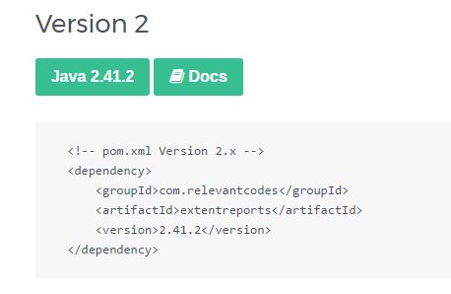

Step2:-

Click on the Java 2.41.2 and download the file

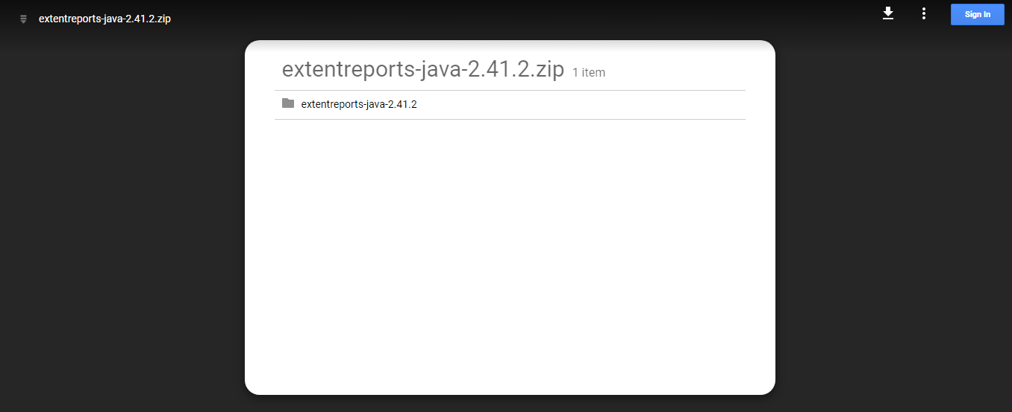

**Step 3:-Extract the file and configure the files on the project build path**